Metadata

Meta Title:
Battery Replacement & Testing in Avondale, AZ | Dodge Ram Avondale

Meta Description:
Schedule battery replacement, installation, or testing at Dodge Ram Avondale. Order a genuine Mopar battery for local pickup.

Domain(s)
https://www.moparwholesaleparts.com/ = Parts department
https://www.avondaledodge.com/ = Dealership / service

URL Structure
/services/battery-replacement

Keywords
- “battery replacement near me” = 12,100 monthly SV
- “battery installation near me” = 2,900 monthly SV
- “battery testing near me” = 2,900 monthly SV

1. Header Banner
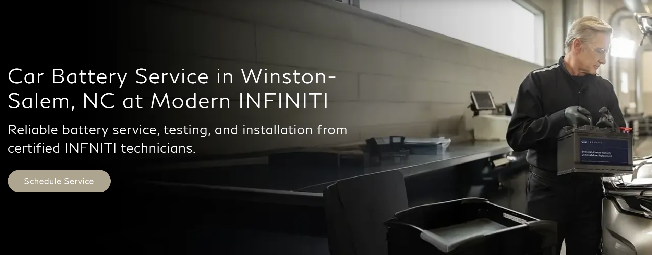

H1 Header Title:
Battery Replacement in Avondale, AZ at Dodge Ram Avondale

Subtitle:
Expert battery replacement, installation, and testing at Dodge Ram Avondale. Schedule service with certified technicians or order a genuine Mopar battery for local pickup.

[ CTA Button Block]
CTA Button
Text | Schedule Service
Link To | https://www.avondaledodge.com/service/our-services.htm

2. Content Block 2: Information
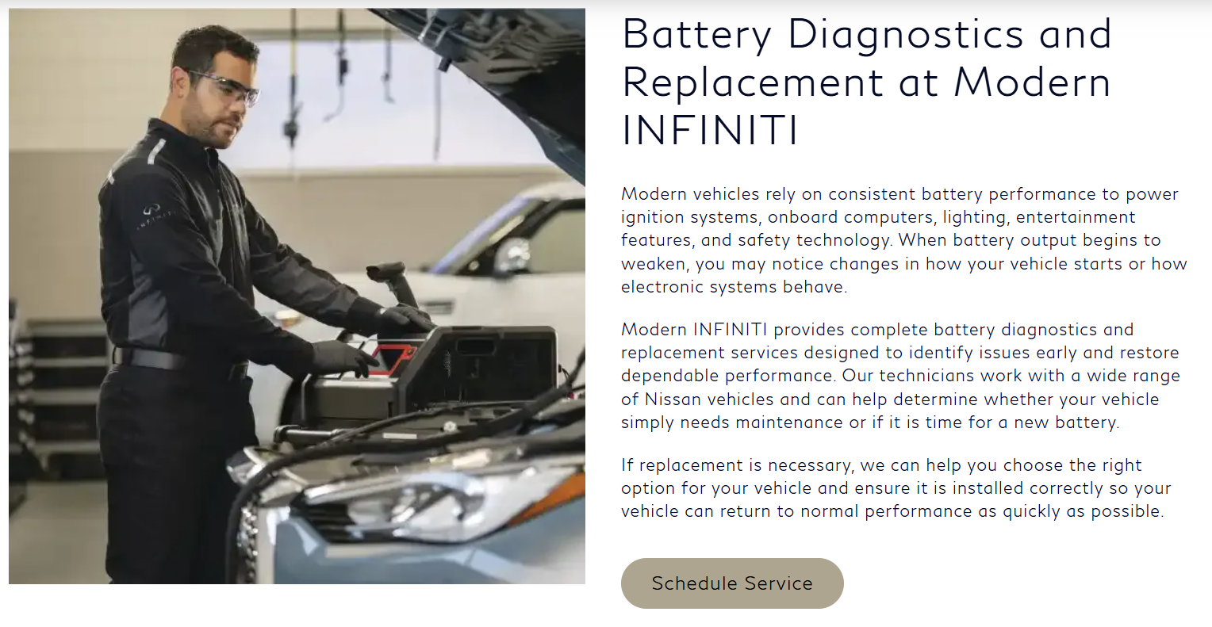

H2 Header:
Battery Replacement & Testing at Dodge Ram Avondale

Body Copy:
Modern vehicles require more than a simple battery swap. Today's electrical systems often require specialized testing and installation procedures to ensure proper operation after a new battery is installed.
Our factory-trained technicians can:
- Perform comprehensive battery testing
- Inspect battery terminals and cables
- Evaluate charging system performance
- Check alternator output
- Install a genuine Mopar replacement battery
- Verify proper electrical system operation
- Properly recycle old batteries
Our goal is to provide an accurate diagnosis and a long-lasting repair solution. Professional battery installation and testing help ensure reliable starting performance and proper functionality of your vehicle's electrical systems.

[ CTA Button Block ]
CTA Button
Text | Schedule Service
Link To | https://www.avondaledodge.com/service/our-services.htm

3. Content Block 3: Information
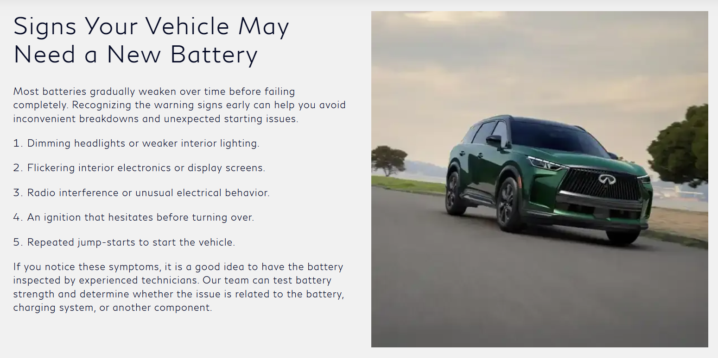

H2 Header:
Signs Your Vehicle Battery May Need Replacement

Body Copy:
Your vehicle's battery naturally loses performance over time. Factors such as age, driving conditions, climate, and electrical system demands can all affect battery health. Routine battery testing can help identify issues early and determine whether maintenance or battery replacement is needed.
Common signs of a failing battery include:
- Slow engine cranking
- Clicking noises during startup
- Dim headlights or interior lights
- Dashboard battery warning light
- Intermittent electrical issues
- Frequent jump-starts
- Corrosion around battery terminals
- Reduced performance of electronic accessories
If you're experiencing any of these symptoms, it's a good idea to have your battery tested. Addressing battery issues early can help prevent unexpected breakdowns and keep your vehicle operating reliably.

4. CTA Block 4: Specials


H2 Header:
Check out our current service specials

Body Copy:
If it's time for a battery replacement, it's a good idea to check out our current service specials before scheduling your appointment. We regularly offer specials on select maintenance and repair services, which may include battery replacement or other routine vehicle maintenance. See the latest offers and save on your next service appointment.

[ CTA Button Block ]
 | CTA Button 1
Text | See Service Specials
Link To | https://www.avondaledodge.com/specials/service-specials-avondale-az.htm

5. Content Block 5: Information
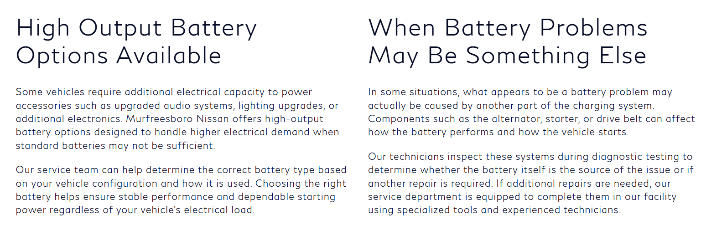

H2 Header 1 (Left side):
High Output Battery Options Available

Body Copy 1 (Left side):
Some Chrysler, Dodge, Jeep®, and Ram vehicles place higher electrical demands on the battery due to added accessories, advanced electronics, or increased power usage. In these cases, selecting the correct battery is critical to maintaining consistent starting power and system performance.
Our service team can help identify the right OEM battery based on your vehicle configuration and how it’s driven. Choosing a properly matched genuine Mopar battery helps ensure reliable performance, stable voltage, and dependable operation under all driving conditions.

H2 Header 2 (Right side):
When Battery Issues May Be Something Else

Body Copy 2 (Right side):
Not all starting or electrical issues are caused by the battery itself. In many cases, components within the charging and starting system can produce similar symptoms.
Parts such as the alternator, starter, or drive belt can all impact battery performance and vehicle reliability. That’s why our factory-trained technicians perform a complete system diagnostic to identify the root cause of the issue before any repairs are recommended.
If additional service is needed, our service department is equipped to complete the repair using OEM parts and specialized diagnostic tools, helping ensure that the job is done correctly the first time.

6. CTA Block 6: Buttons


H2 Header:
Buy Your Mopar Battery Online

[ CTA Buttons Block ]
 | Button 1 | Button 2 | Button 3
Text | BUY ONLINE | PICKUP | DELIVERY
Link To | https://www.moparwholesaleparts.com/c/charging-starting-systems/batteries

7. CTA Block 7: Product Widget

H2 Header:
Featured Replacement Batteries
[ Product widget ]
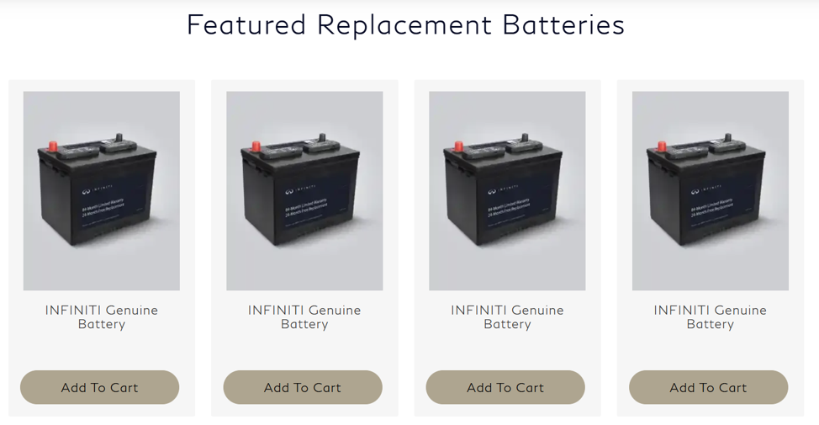
[ CTA Banner 3 ]


CTA Banner 3 H3 Header:
Let us find the right battery for you

Banner Copy:
Use our fitment tool or contact us. Our experts will help you find the right genuine Mopar battery in minutes.

[ CTA Buttons Blocks ]
 | CTA Button 1 | CTA Button 2
Text | Shop All Batteries | Call Us
Link To | https://www.moparwholesaleparts.com/c/charging-starting-systems/batteries

8. Content Block 8: Information
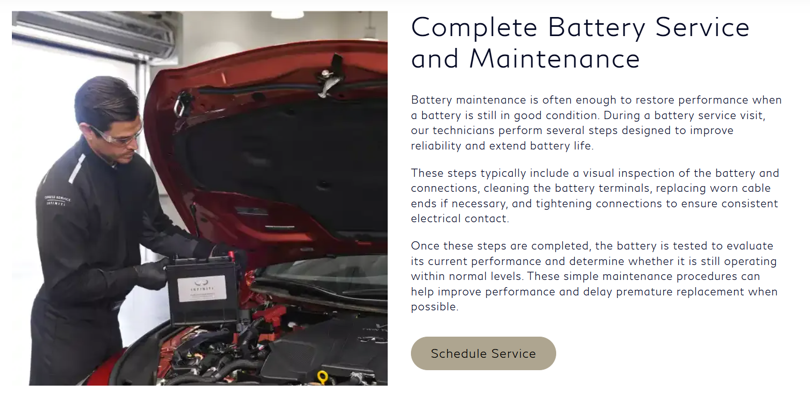

H2 Header:
Order Your Battery Replacement Online and Pick It Up Locally

Body Copy:
Many drivers choose to order their replacement battery in advance and pick it up directly from their local dealership parts department. By ordering ahead, you can ensure the correct battery for your exact make and model is ready when you arrive. This helps eliminate guesswork, reduces wait time in the service lane, and gets you back on the road sooner with a reliable, factory-approved solution.
Ordering online or by phone and picking up in-store allows you to streamline the entire repair process. In many cases, you can coordinate battery installation during the same visit or bring your part directly to a trusted technician for immediate service.
This approach is ideal for drivers who want:
- Minimal downtime
- Confidence in part availability before arrival
- A straightforward, no-surprise service experience

[ CTA Button Block ]
CTA Button
Text | Shop All Batteries
Link To | https://www.moparwholesaleparts.com/c/charging-starting-systems/batteries

9. Content Block 9: Information
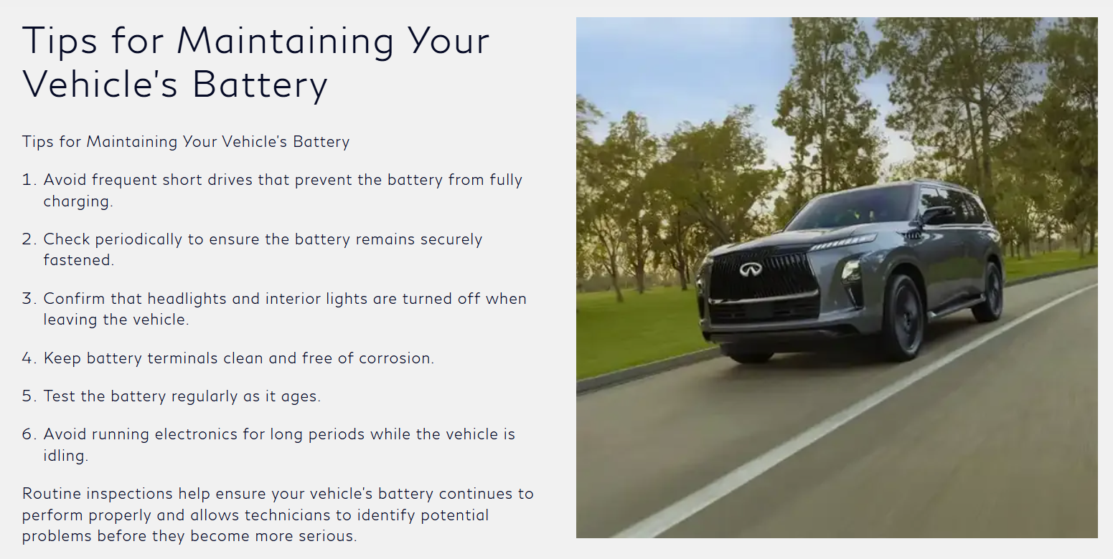

H2 Header:
Tips for Maintaining Your Vehicle’s Battery

Body Copy:
A few simple maintenance habits can help maximize battery performance and reduce the likelihood of unexpected starting issues.
- Limit frequent short trips that may not allow the battery to fully recharge.
- Make sure the battery remains properly secured within its mounting tray.
- Turn off headlights, interior lights, and accessories before exiting the vehicle.
- Keep battery terminals clean and free of corrosion.
- Have the battery tested periodically, especially as it approaches the end of its expected service life.
- Avoid prolonged use of electronics when the engine is off.
Regular battery inspections can help identify potential concerns early and ensure your vehicle has the power it needs to support reliable starting and everyday performance. If service or replacement is needed, trust genuine Mopar parts and factory-trained technicians to help keep your Chrysler, Dodge, Jeep®, or Ram vehicle operating at its best.

10. Content Block 10: FAQs
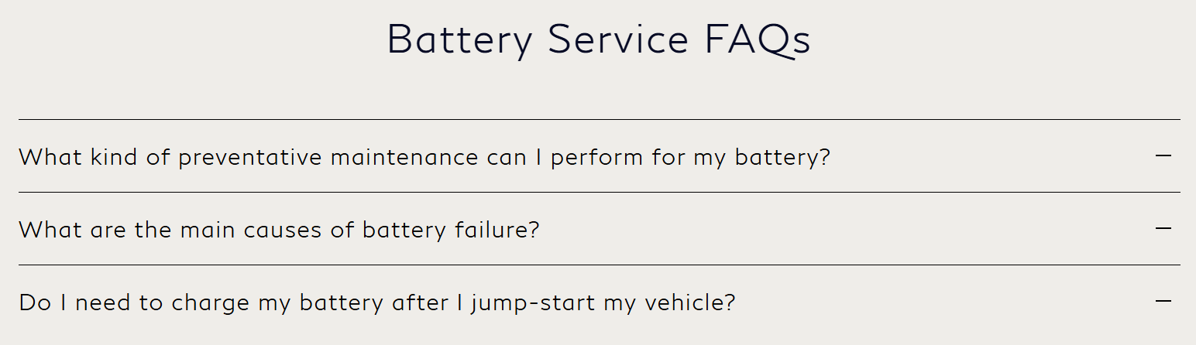

H2 Header:
Battery Service FAQs

FAQ Content:

H4: How often should I have my battery tested?
Battery testing should be performed regularly, especially once your battery is more than 3 years old. Routine testing can help identify declining performance before a failure occurs.

H4: How often should I replace my vehicle battery?
Most vehicle batteries last between 3 and 5 years, though factors such as climate, driving habits, and vehicle usage can affect overall battery lifespan. Scheduling regular battery testing at your local Mopar service center can help you stay ahead.

H4: How long does battery replacement take?
Most battery replacement services are completed quickly during a scheduled visit. Some vehicles may require additional system checks or reset procedures, which your local Mopar technicians can perform as part of the service.

H4: What are the signs of a failing battery?
Common signs include slow engine cranking, dim or flickering lights, electrical malfunctions, dashboard battery warnings, corrosion on terminals, and the need for frequent jump-starts. If you notice these symptoms, it’s a good time to schedule a professional battery inspection at a Mopar service center.

11. Content Block 11: Local Information
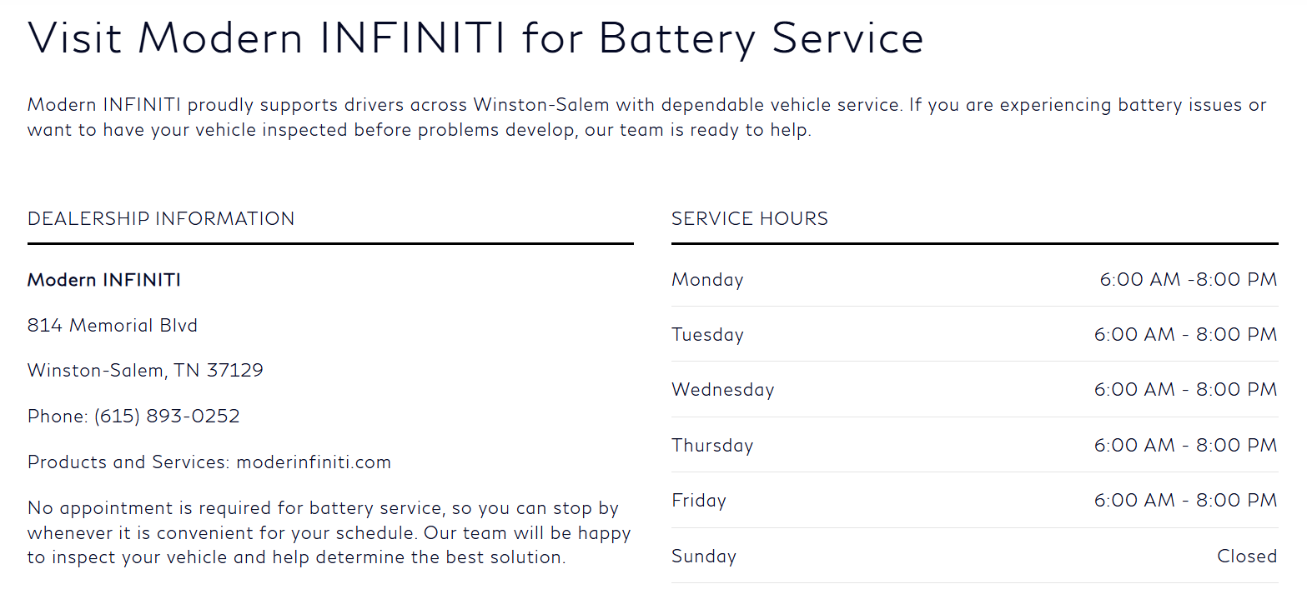

H2 Header 1:
Visit Dodge Ram Avondale for Battery Service

Body Copy 1:
Dodge Ram Avondale is proud to support drivers throughout Avondale, AZ with professional battery testing, battery installation, and battery replacement services.
Whether you're dealing with battery issues or simply staying ahead of routine maintenance, our factory-trained technicians can help diagnose the issue and recommend the right solution to keep your Chrysler, Dodge, Jeep®, or Ram vehicle performing at its best.

[ Dealership / Service Hours Info Block ]
Dealership Information Block | Service Hours Block
Larry H. Miller Dodge Ram Avondale  10101 W. Papago Freeway  Avondale, AZ 85323-5306  Sales: 623-469-6170  Service: 623-469-7496  Parts: 623-299-7021 | Monday | 7:00 AM – 6:00 PM
 | Tuesday | 7:00 AM – 6:00 PM
 | Wednesday | 7:00 AM – 6:00 PM
 | Thursday | 7:00 AM – 6:00 PM
 | Friday | 7:00 AM – 6:00 PM
 | Saturday | 7:00 AM – 4:00 PM
 | Sunday | Closed

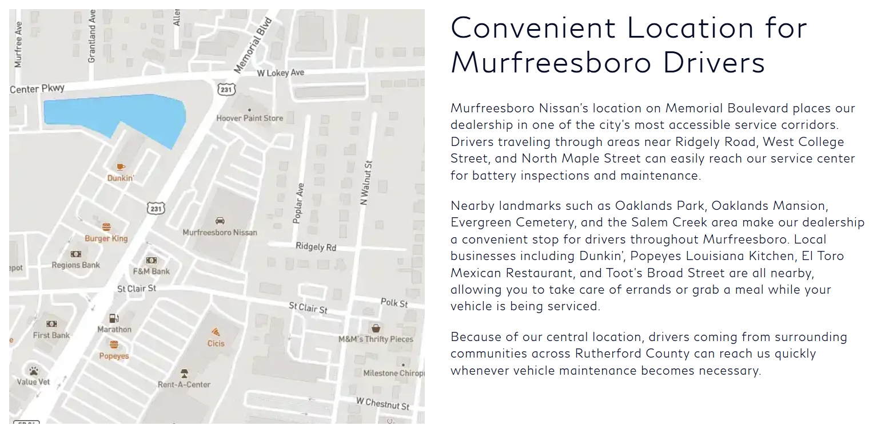

H2 Header 2:
Convenient Location for Avondale Drivers

Body Copy 2 (Local-Focused):
Located in Avondale, AZ, our dealership is easily accessible to drivers throughout the West Valley, including Goodyear, Litchfield Park, Tolleson, and surrounding communities. Whether you're commuting along I-10, traveling near Loop 101, or running errands close to home, our service center is positioned for convenient access when you need battery diagnostics or replacement.
Nearby destinations such as the Phoenix Raceway, Gateway Pavilions, and the Avondale Civic Center make it easy to plan your visit while your vehicle is in service. Local shopping, dining, and retail options throughout Avondale and nearby Goodyear also allow you to stay productive while we take care of your vehicle.
With a central West Valley location and full Mopar service capabilities, Dodge Ram Avondale makes it simple to get the battery service or genuine OEM parts that your vehicle needs, when you need them.
CTA Button
Text | Schedule Service Now
Link To | https://www.avondaledodge.com/service/our-services.htm

12. Footer Newsletter Sign Up CTA


H3 Header:
Sign Up for Mopar Parts & Accessories Offers

